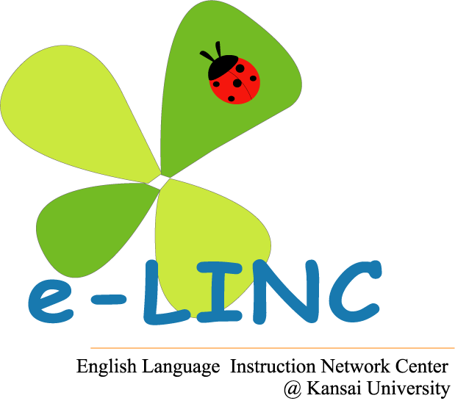

2013年度 e-LINC 招聘講演②
Dr. Hossein Nassaji

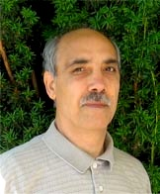
Hossein Nassaji is Professor and Chair of the Department of Linguistics, University of Victoria, Canada. His teaching and research interests include form-focused instruction, corrective feedback, and L2 classroom discourse. His research has been published in numerous leading journals in the field including Language Learning, Applied Linguistics, Applied psycholinguistics, Modern Language Journal, TESOL Quarterly, and International Review of Applied Linguistics.
Interactional feedback and focus on form:
What have we learned from current research?


Recent second language acquisition (SLA) research has demonstrated a need for instructional activities that integrate form-focused instruction with communicative interaction in L2 classrooms. However, how this need should be addressed has been the focus of much debate in the literature. There are different ways of integrating focus on form into a classroom communicative context.
In this talk, I will examine one way of doing so, which is through interactional feedback, that is, feedback generated through various negotiation and modification strategies that occur in the course of communicative interaction. I will begin by presenting a taxonomy of interactional feedback. Then, drawing on recent theory and research, I will explore some of the key issues and controversies surrounding its role in language acquisition, including how it is used, the different ways in which and the extent to which it affects L2 acquisition, the cognitive mechanisms utilized in its processing, and the role of various factors that can impact its effectiveness. I will conclude by discussing the insights that can be derived from such examination for how to provide effective feedback in L2 classrooms.

日時：2013年10月11日（金）18:00～19:30（6時限目）
場所：関西大学 千里山キャンパス 岩崎記念館４階F401教室

たくさんの方のご参加、お待ちしております！

