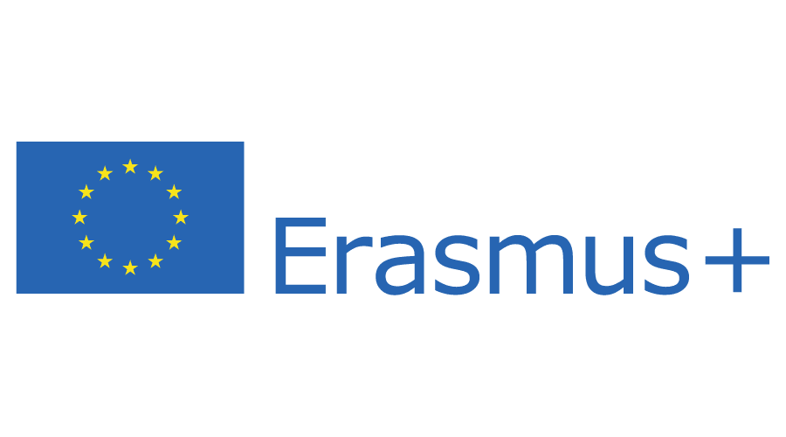

APPLICATION FORM FOR
ERASMUS+ KA107 INCOMING STUDENTS
ERASMUS+ PROJECT 2020-1-HR01-KA107-077450

NOTE: This application should be printed, filled, signed by student and endorsed by the sending (home) institution!

PERSONAL INFORMATION

Name and surname: ___________________________________________________________

Date of birth: (dd/mm/yyyy) ___________________________ Place of birth __________________________
Citizenship: _______________________________ Sex: M F
E-mail: ___________________________________
Home address: ______________________________________________________________
Mailing address (if different): _____________________________________________________

INFORMATION ABOUT THE STUDIES AT HOME INSTITUTION
Name of the home institution: ___________________________________________________

Name of the study programme at home institution: __________________________________

Current level of study: Bachelor
Master
PhD

INFORMATION ABOUT THE INTENDED STUDIES AT UNIVERSITY OF ZADAR
Academic year 20____ / 20____
Name of the home department: __________________________________________________
All exchange students must choose one main Department where more than 50% ECTS will be achieved.

Duration of mobility: Academic year
Winter semester
Spring/Summer semester
If different, please specify: from __________ till ___________

FOREIGN LANGUAGE KNOWLEDGE

Mother tongue:
 | Excellent | Very good | Good | Sufficient
English
Croatian
Other languages:

- Please read the language requirements on our web page: http://www.unizd.hr/eng/international-relations/student-mobility/language-requirements

PREVIOUS PARTICIPATION IN ERASMUS+ PROGRAMME

Have you already participated in the Erasmus+ programme?

YES NO

If yes, please provide mobility dates and the name of host institution:

___________________________

DOUBLE FINANCING DISCLAIMER
By submitting this application, under criminal and material responsibility, I declare that no other scholarship originating from the European Union was awarded to me for the purpose of mobility I am applying for.

CONSENT TO DISCLOSURE OF PERSONAL INFORMATION
By submitting this application I confirm that I have read and understood all the provisions of the Call for Applications for the Erasmus+ project No.: 2020-1-HR01-KA107-077450 and that I will comply with its terms and conditions. Also, by submitting this application I give my consent to the University of Zadar, acting as a coordinating institution, to publicly disclose my personal information and my mobility activity data before, during and after the mobility period.

I hereby declare that all the information provided in the application is to my best knowledge, correct and complete.

Date and place: Student’s Signature:

____________________ _______________________

SENDING (HOME) INSTITUTION ENDORSEMENT:

To be filled by the responsible person at the sending institution:

Name of the institution: _______________________________________________________

Name and surname of the responsible person:_______________________________________

E-mail: _____________________________________________________________________

Phone: _____________________________________________________________________

Herby I confirm that the student_______________________________________ (name and surname of the student) is enrolled in the _______________ year (year and level of study eg. 2 MA) of the study programme: ______________________________________________________ (name of the study programme) at the ___________________________________________________ (name of the institution/university) and therefore I endorse his/her application for Erasmus+ mobility at the University of Zadar.
It is also confirmed that the above mentioned student’s English language skill is equivalent to B2 level of on the CEFR** scale.

Date and place: Responsible person’s signature and stamp:

________________________ ______________________________________

Please note that fluent language skills are vital for successful studies at the University of Zadar. If the language requirements are not met, the University of Zadar will not accept the student and reserves the right to do so even after arrival!

** CEFR - Common European Framework of Reference for Languages URL: http://europass.cedefop.europa.eu/en/resources/european-language-levels-cefr

DOCUMENTS TO BE ATTACHED TO THE APPLICATION FORM:

NOTE: This application should be printed, filled, signed by student and endorsed by the sending (home) institution!

- Transcript of Records (for bachelor level: transcript of all bachelor courses taken so far; for master level: copy of bachelor diploma and transcript of both bachelor and master courses taken so far) with explanation of the grading system;
- Proof of citizenship (copy of passport or ID card);
- Motivation letter;
- CV in the Europass Form.

These documents have to be sent in English as PDF files to erasmus@unizd.hr.

